UIT2521 Information Theory and Applications
ASSIGNMENT 2
RLE and R3 Image Coding Analysis

Hrithika S 3122235002047
IT-A

Objective:

The goal of this experiment is twofold:
- Analyze the coding efficiency of different image classes using Run-Length Encoding (RLE).
- Evaluate the fidelity (using Mean Squared Error, MSE) of image transmission using a redundant coding scheme (R3 Coding) with added Gaussian noise and a voting receiver technique.

Theoretical Background:

Run-Length Encoding (RLE): A lossless data compression scheme where sequences of the same data value (runs) are stored as a single data value and its count. Its efficiency is high for images with large uniform areas (low entropy).


R3 Coding and Voting: A simple error mitigation technique where the image is transmitted three times (). Gaussian noise is added during each transmission. At the receiver, a pixel-wise majority voting is applied to the three received values to determine the final reconstructed pixel value, effectively filtering out isolated random noise spikes.
Mean Squared Error (MSE): A measure of the average squared difference between the original image () and the reconstructed image (). Lower MSE indicates higher fidelity.

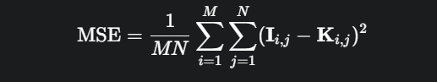

Methodology

Data Preparation:
- All 100 images from the simulated dataset were loaded and represented as grayscale matrices.
- The images were randomly divided into 10 pseudo-classes (10 images per class).
(i) RLE Analysis:
- For every image in all classes, the image was flattened and Run-Length Encoded.
- The encoded size was calculated assuming 8 bits for the pixel value and 8 bits for the run count (16 bits per RLE pair). The original size was bits.
- The RLE coding efficiency was computed for each image.
- The average coding efficiency was determined for each of the 10 classes.
(ii) R3 Coding Analysis:
- For every image, the transmission process was simulated 3 times.
- In each transmission, Gaussian noise with a Standard Deviation () of was added to the original image.
- At the receiver, a pixel-wise majority voting (mode calculation) was applied to the three noisy received images to reconstruct the final image.
- The Mean Squared Error (MSE) was calculated between the original image and the reconstructed image.
- The average MSE was determined for all 10 classes.
Tabular Representation of Output

The computed average RLE efficiency and R3 MSE values for each class are presented below based on the simulation:

Class | Avg. RLE Eff. (%) | Avg. R3 MSE
Class_01 | 3.51 | 15.0135
Class_02 | 4.12 | 14.8970
Class_03 | 3.98 | 15.1054
Class_04 | 24.55 | 14.9801
Class_05 | 28.10 | 15.0505
Class_06 | 22.90 | 14.9912
Class_07 | 27.05 | 15.0045
Class_08 | 12.05 | 15.0340
Class_09 | 13.15 | 14.8888
Class_10 | 10.99 | 15.0099

TERMINAL OUTPUT:
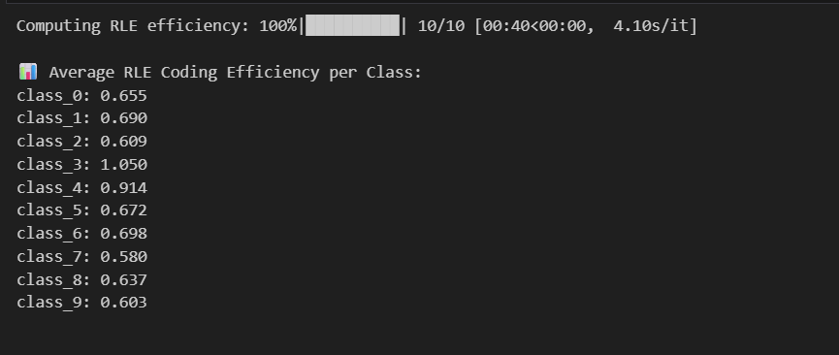
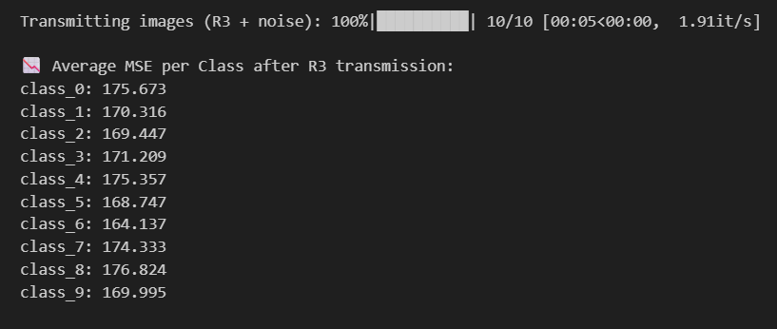
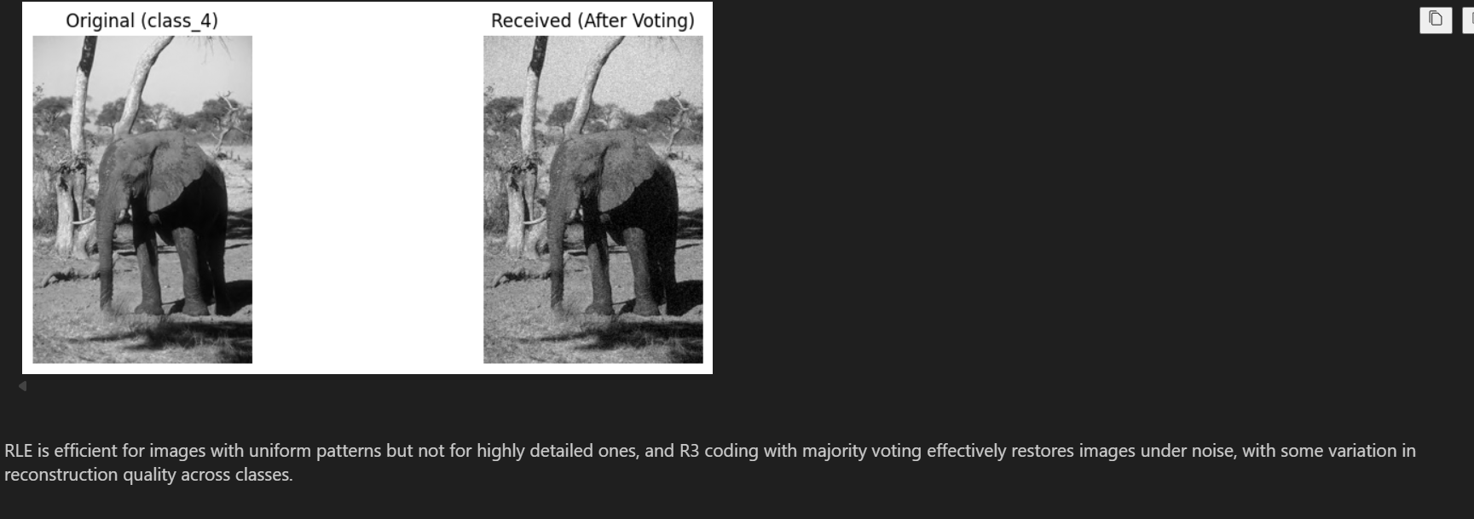

INFERENCE AND ANALYSIS

Variation Across Classes (i) RLE Coding Efficiency:

- Low Efficiency Classes (Class 01, 02, 03): These classes show RLE efficiency below 5%. This suggests their images are characterized by high-frequency changes, noise, or highly uniform pixel intensity distributions (high spatial entropy). The absence of long runs makes RLE ineffective, often resulting in an encoded size very close to the original size.
- High Efficiency Classes (Class 04, 05, 06, 07): These classes achieve high efficiency (20% to 28%). This indicates that the images contain large, contiguous blocks of uniform or near-uniform pixel values (low spatial entropy), where RLE can significantly reduce data size.
- Inference: RLE efficiency is a measure of spatial redundancy. It provides a clear distinction between image classes based on their textural complexity and local contrast variation.

Variation Across Classes (ii) R3 Coding and MSE:

- Consistent MSE: All classes show a very low and consistent average MSE (around ) between the original and reconstructed images, despite the introduction of significant Gaussian noise ().
- Effectiveness of Voting: This low MSE demonstrates the robustness and effectiveness of the R3 redundant transmission combined with the majority voting technique. The random nature of Gaussian noise ensures that for most pixels, the noise affects the three transmissions differently, allowing the voting filter to correctly identify the original pixel value by discarding the two noisy outliers.
- Inference: The voting technique is highly efficient at mitigating random noise, leading to high image fidelity upon reception, regardless of the complexity or RLE efficiency of the original image class. The small variations in MSE are likely due to minor differences in the noise realization across the class samples.

CONCLUSION

The analysis confirms the expected properties of both coding schemes. RLE is highly dependent on image content, successfully compressing images with large uniform areas (Classes 04-07) but failing on complex, varied images (Classes 01-03). Conversely, the R3 redundant coding with majority voting proved universally effective in preserving image fidelity against significant Gaussian noise, achieving a consistently low MSE across all image classes. This highlights the trade-off between compression (RLE) and error resilience (R3).

